Project 1 – MAE 5540 Propulsion Systems

For this project, I created a program that would use the Trapezoidal Rule and Runge-Kutta techniques to integrate the equations of motion for a rocket. This allows the program to predict the trajectory of a rocket given the characteristics of the rocket motor and an initial mass. Table 1 shows the results from my program.

Table 1: Results

|  |  |  |  |  |
| --- | --- | --- | --- | --- |
|  |  | Part a | Part b | Part c |
| Initial Conditions | Mass(kg) | 1078 | 1649.455 | 1650.2 |
| Time step (s) | 1 | n/a | 0.5 |
|  |  |  |  |  |
| First Burn | Impulsive? | no | yes | no |
| Thrust (N) | 10 | 2000 | 2000 |
| Isp (s) | 2000 | 270 | 270 |
| Mass used (kg) | 70.21136 | 382.64950 | 383.85486 |
| Delta V (km/s) | 1.32085 | 0.69883 | 0.70099 |
|  |  |  |  |  |
| Second Burn | Impulsive? | yes | yes | no |
| Thrust (N) | 2000 | 2000 | 2000 |
| Isp (s) | 270 | 270 | 270 |
| Mass used (kg) | 7.521133 | 266.80646 | 265.96121 |
| Delta V (km/s) | 0.01983 | 0.62616 | 0.62418 |
|  |  |  |  |  |
| Totals | Final Mass (kg) | 1000.267507 | 1000 | 1000.38393 |
| Total Delta V | 1.34068 | 1.32499 | 1.32517 |

The EP device in part a used up considerably less fuel that the stronger rocket motors used in parts b and c. Also, there is little difference between the impulsive and non-impulsive burns in terms of mass used and total delta V. There was little difference from the two integration schemes Trapezoidal and Runge-Kutta. The time step had a significant impact on the accuracy of the continuous thrust burn. The integration methods fail at higher time steps around 500 sec.

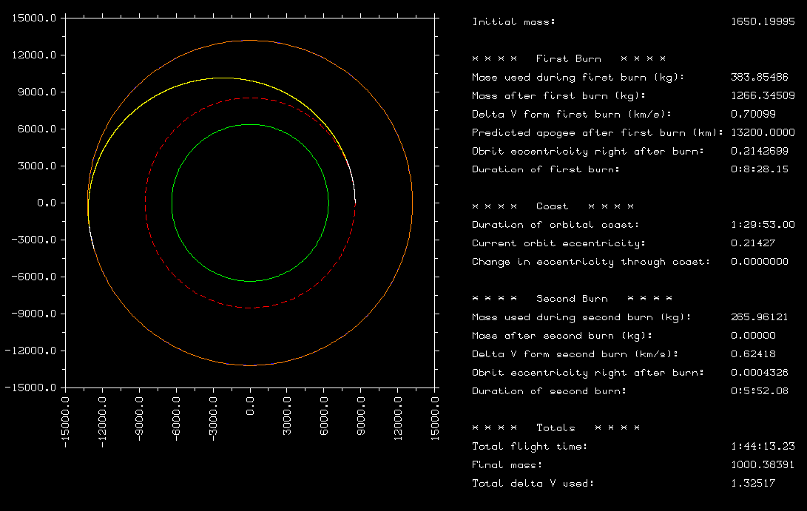

Figure 1: Part C Display

For the non-impulsive kick problem in part c, I decided to start the second burn a little early. I did this by approximating the delta v that I needed based on an impulsive calculation. I then used that to determine how much fuel I needed. Then I compared this predicted amount of fuel with the mass flow rate based on this motor (thrust and Isp) to approximate the time required to burn. Then I halved this time and subtracted it from my expected time to arrive at apogee from my coast. This method seemed to work pretty well, as can be seen in Figure 1. The white lines on figure 1 represent the rocket burn. The dashed red line shows the Leo Orbit while the dashed blue line (which can’t be seen) shows the Meo Orbit. The yellow line shows the trajectory of the rocket during coast. The orange line shows the instantaneous orbit after the second burn. The orange line overlaps the dashed blue line.